Supplemental Reading Notes to Prepare for Effective Strategic Thinking
W. C. Schulz, PhD, Walden University
Introduction
The MBA Competencies, SF005–SF007, are considered Capstone Competencies, where you will be expected to integrate knowledge from throughout all of your already-completed MBA Competencies. The aim of these Capstone Competencies is to improve your ability to think strategically about larger-scale problems that are cross-disciplinary, and often ambiguous and contradictory, so that you can participate more fully in organizational efforts to improve long-term performance and engagement within the larger stakeholder environment.
As such, you will be taking a general management and senior leadership perspective in all of your analyses and recommendations for these competencies. That means that you must be able to thoughtfully consider and discuss the implications of your recommendations in terms of, and across, all of the major core functions of business, including finance, accounting, marketing, innovation management, and general leadership.
While we don’t expect that you are, or may become, a CEO in the short-term, it is critical that you be able to understand the integrative strategy problems of general and senior managers, and that you be able to serve senior managers when the time comes.
Miyamoto Mushasi, who was a great Japanese swordsman in the 1600s, thought carefully about the role of strategy and strategic thinking and practice. He suggested that one of the very core skills that a strategist requires is to be able to see things far away—as if they were close; and to see things close—as if they were far away.
These Competencies will give you a chance to practice this skill, and it will challenge you to move from the specific to the general, and from the general to the specific.

Strategic Situation Analysis
Perform strategic situation analyses and make recommendations to senior leadership with respect to strategy development and execution.

Assessments SF005 and SF006 require you to create a Situational Analysis Portfolio based on eight case studies, and then to create an original “Strategy Playbook” for a chosen organization. The case study assessment is intended to help you exercise and demonstrate individual analysis Competencies, to prepare you to be able to develop the “Strategy Playbook.” To get the most out of each case study, review the following:
The Case Study Process
Before you jump into case analysis, let’s examine the case learning method itself, particularly as it relates to our online approach to using it as a tool for integrative learning. In John Hammond’s 2002 teaching note, “Learning by the Case Method,” he reminds us that part of the fun—and the difficulty—of cases is that, for them to be effective, “you must put yourself in the shoes of the managers, analyze the situation” (given the facts of the case and no more), “decide what you would do”, and then articulate and tell your assessor why and how your ideas are relevant and feasible. We’ve selected cases that are relevant to the primary topics and readings/skills for each Competency, and which we think will help you integrate your previous learning (from throughout your program).
This means that you should refresh yourself on the topics of your previous Competencies, as you will be expected to utilize information and knowledge from all of those courses as you prepare responses to the Assessment questions and follow-up prompts from your mentor and assessor. It is critical that you go well beyond “opinion” and have a well-crafted argument that supports your ideas in a case analysis. Anyone can have an opinion, but as a soon-to-be MBA, people will expect that you can defend your analysis and persuade them!
Read the Hammond teaching note in the course resources closely, and mark those instances where he discusses “analysis, analytic viewpoint, analytical skills, and expertise.” Case analysis is about identifying core problems and crafting potentially feasible solutions and actions for the future. It is not easy, and it will force you to work within many ambiguous, uncertain, risky decision contexts. That’s OK, and it’s the world that CEOs and senior leaders live in—so if you are feeling uncomfortable at times doing your casework, keep with it!
Note: Case studies often have dates associated with them. Sometimes you will find a case that you might consider “old.” Don’t be fooled into thinking just because a case is “old” that it is not relevant or important. All case studies are snapshots in time that have been developed to help you learn a particular concept or skill. You are to analyze the case within the information set provided—so in this way “absolute date” is irrelevant. So don’t let the dates of cases worry you.
Reference: Hammond, J. S. (2002). Learning by the case method [Teaching note]. Boston, MA: Harvard Business School of Publishing.

The Strategic Analysis Thinking Process
Figure 1, below, illustrates the broad strategic thinking analysis process that should guide how you classify each specific type of strategic situation analysis. Some of the case studies in your SF005 Assessment will require specific analytic tools to help you respond to the questions at hand, while the major “Strategy Playbook” Assessment in SF006 will require that you conduct a complete and integrated analysis of a single organization, using all the analytic thinking processes indicated in Figure 1: The Strategic Thinking Analysis Process.

Figure 1: The Strategic Thinking Analysis Process
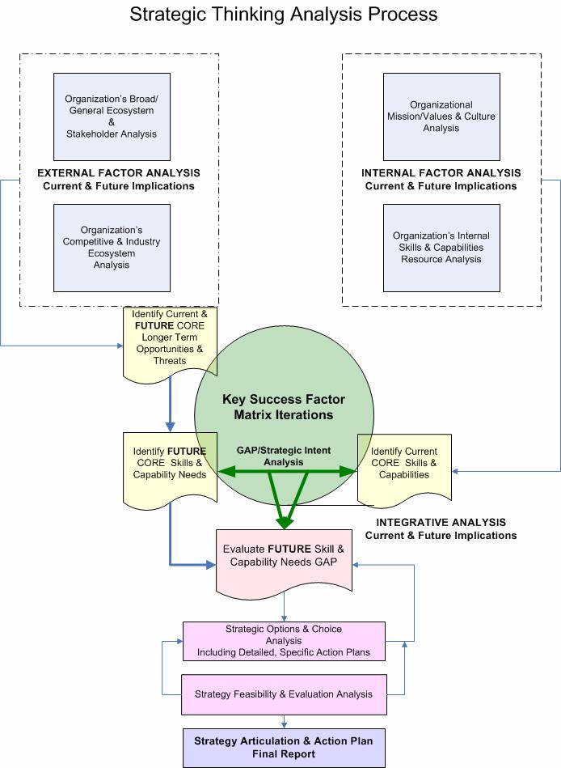

Notice that the flow of the thinking process includes: (1) internal analyses of the culture, mission and soulful purpose of the company, as well as a detailed analysis of the company’s current internal skills, competencies and capabilities (SCC, its resource base); (2) external analyses of the most broad ecosystem and stakeholder influences, and then more discrete competitive industry analysis; and, (3) integrative analysis, which takes information from the prior analyses and which features an iterative process, which uses the key success factor analysis to help you identify critical gaps between current skills and capabilities, and future skills and capability needs.
Depending on what conclusions you reach during this iterative GAP analysis, you then assess the potential feasibility of your recommended (specific) strategic action plans. If your plan does not seem feasible, then you repeat the iterative process to assess an alternate plan. Once you’ve developed an action plan that appears feasible and consistent, you can write up the final report—using references and materials from all the individual analyses to help you.

Supplemental Case Analysis Information: What are the Core Skills, Competencies, and Capabilities of Trader Joe’s?
For the Trader Joe’s and the U.S. food retailing industry case, you are being asked to evaluate the skill/competence and capability basis for why Trader Joe’s is doing so well within the industry. You are provided a detailed value-chain to help you rate these elements, and you should be able to find relevant information in the “Business Source Complete” databases, as well as others.
In order to help you understand the relationship between skills, competencies and capabilities, and potential sustainable advantage, review the section below:
The Living Organization
All strategic (or not strategic!) actions, indeed, all value creation by an organization, is done through the application of skills (what individual people can do—think in terms of active verbs), competencies (what groups of individuals can do—think organization functions), and capabilities (what supporting plant, machinery, software, and systems/processes, etc.) can do.
Therefore, the heart and the core of all organizations is their people, and the culture that both attracts and hopefully retains talented and passionate individuals and teams (through style, shared values, and structure). Wolfe (2009, pp. 63–67; 81–90) talks about this concept as “The Living Organization” and identifies three “levels of analysis” that comprise every company: (1) The Activity Field, which encompasses individuals, departments/functions (groups of people) and what they do (or can do—exhibiting classical skill-intelligence); (2) The Relationship Field, which encompasses how individuals and groups communicate and interact with one another (and exhibit emotional intelligence); and, (3) The Context Field, which encompasses the organizational culture and connections to a greater purpose (which you analyzed earlier).
To truly understand the current and potential capability of an organization, it is critical that you identify, analyze, and evaluate all three levels of analysis in detail (and iteratively), and that you come to an integrated understanding of the alignment (or non-alignment) of the organization as a living entity with ambitions, a core purpose, that is also aligned with skills, competencies and capabilities that can be used to drive a future strategy.
All Things Start With the Energies and Skills of People
Wolfe (2009, p. 63) calls on leaders at all levels of an organization to “view the organization as a living system, directing the flows of energies [passions and skills] within that body of people and transforming their collective energy [relationships and shared values] and effort into the products and services brought to the marketplace [to meet the organization’s Soulful Purpose].”
Perhaps the easiest way to understand the concept of skill is to recognize that all skills reside in people, and that individual people have many, many thousands of skills. A skill is any activity that you can describe in “action verb” form (i.e., to sell, to write effectively, to sculpt, to think creatively, etc.). When groups of people share a set of skills that are applied in a coordinated way, it is called an organizational competence. Traditional business functions, such as marketing, product development, production and operations, and finance, are areas for potential organizational competencies; so are any specialized cross-functional teams, etc. A capability is like a skill but it resides in physical resources, such as equipment, software, the functionality of furniture, a building location (functionality of location), etc. However, the deployment of capabilities is still the result of the application of skills by someone—so nearly all good strategy emerges from what might be called a “skill-based, resource-based view of the firm.”
As such, it is critical to analyze what skills, competencies, and capabilities an organization actually has—and how these energies can best be tapped to ward off external threats, seize on opportunities, and navigate into new “blue oceans” of value creation. In order to be effective in this kind of analysis, we have to drill deeper into the relationships between skills/competencies and capabilities, and what is often called “strengths” and “weaknesses,” because there is a big difference between the concepts.
Towards a More Precise “SWOT” Analysis: SCOT Internal Analysis and Competitive Potential
One of the primary goals of effective strategic thinking is to allow you, as an analyst, to come to a “big picture understanding” of the elements of both the internal world of a business, and the external elements that affect a business. Strategic choices are born between the spaces of opportunities and threats in the external environment on the one hand, and the current and future skills, competencies, and capabilities of the company on the other (including strategic intent stretching).
A traditional “SWOT Analysis” (Strengths, Weaknesses, Opportunities and Threats) is one of the more simple and powerful strategic-thinking tools that provides such a big-picture view of a firm’s potential strategic choices. Indeed, the SWOT idea drives the very structure of this strategic thinking tool set, and it begins with a thorough analysis of the resources of a company—which help us understand what the sources of past success have been, and provides us with a basis to identify what future skills, competencies, and capabilities we think will be needed for the future.
However, there is a small, but important, clarification that we should make to SWOT analysis. Many times during a SWOT analysis, strategists will identify “strong financial position” or “strong brand loyalty” as a strength but will fail to identify the specific resources that allowed those advantages to arise. Static (or stock) resources like cash, reputation, brand loyalty, product quality, etc., are the result of past skills, competencies and capabilities being applied—and these may not necessarily be relevant to future competitiveness!
If we are to really understand a company’s competitive potential, we need to understand the sources of its competitiveness—that is, its skills (all the things a company could be good at because of specific people that are part of the company), its competencies (all the things that teams/functions of people in the company are good at collectively), and its capabilities (all the things a company could be good at because of its investment in productive equipment, software, facilities, locations, and other physical supporting assets).
This distinction is important because, as a good strategic thinker, we want to understand the specific sources for a strong financial position or strong brand loyalty. Having strong brand loyalty came from having skilled people and marketing functions, and appropriate systems and infrastructure to support them. If those underlying skills and capabilities are not maintained or refreshed, future loyalty is not assured. In this way, “brand loyalty” is not a competitive strength one can depend on in the future, it is a competitive weapon that is the result of key skills and capabilities that the company (might) still have.
Since a company controls, and can invest in, skills (people), competencies (teams of people and functions), and capabilities (assets to support people) but cannot directly invest in “brand loyalty,” and since a strategy is ultimately about who and what to invest in (towards a chosen endpoint), we are much better off conducting a SCOT analysis (Skills, Capabilities, Opportunities and Threats) than a more imprecise SWOT analysis.
When we have competitive weapons, that resulted from past investments in skills and capabilities (such as, cash or brand loyalty), the goal is to understand how to best leverage them now, and assure that they will continue into the future. Such continuation is always a function of appropriate reinvestment back into strategic skills and capabilities.
Reference: Wolfe, N. (2011). The living organization: Transforming business to create extraordinary results. Irvine, CA: Quantum Leaders Publishing.

Please Go to the Next Page

In summary, here is how the logic of a SCOT analysis works—and what you will be doing:

Skills (or lack of) & Capabilities Competitive Weapons + New Skills & Capabilities Future Potential
Past & Current Skills Current & Future Skills
Current
Competitive Weapons Outcomes + = Future Competitiveness

Past & Current Capabilities Current & Future Capabilities

What we previously invested in What we could/should invest in

